**Comprehensive Digital Marketing For Apollo Hospitals**

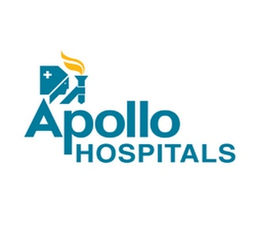**INTRODUCITION:**

Apollo Hospitals is a leading healthcare institution and one of the largest integrated healthcare providers in India and globally. Established in 1983 by Dr. Prathap C. Reddy, the Apollo Hospitals Group has revolutionized the healthcare landscape in India and has become synonymous with high-quality medical care, advanced technology, and compassionate patient-centric services. .

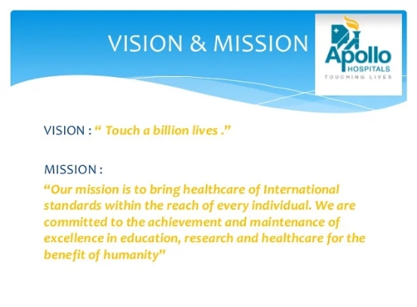**MISSION AND VISION:**

Apollo Hospitals' mission is to bring world-class healthcare within the reach of every individual. They are committed to delivering exceptional medical outcomes through cutting-edge technology, experienced medical professionals, and a patient-centric approach. Their vision is to be the preferred choice for healthcare and medical services globally, driven by clinical excellence, personalized care, and ethical practices.

* Network and Facilities:

Over the years, Apollo Hospitals has expanded its presence across India and beyond, with a vast network of hospitals, clinics, and diagnostic centres. These facilities are equipped with state-of-the-art medical infrastructure and staffed by highly skilled medical professionals across various specialties. Apollo Hospitals offers comprehensive healthcare services, including preventive care, diagnostics, treatment, and rehabilitation, catering to both domestic and international patients.

* Medical Expertise:

The hospitals under the Apollo banner boast a team of renowned doctors, surgeons, nurses, and support staff who are experts in their respective fields. They are committed to delivering the highest standards of medical care, using the latest advancements in medical technology and evidence-based practices.

* Specialties and Departments:

Apollo Hospitals offer a wide range of medical specialties, including but not limited to cardiology, oncology, neurology, orthopaedics, gastroenterology, paediatrics, obstetrics and gynaecology, nephrology, and many more. The hospitals also have specialized centres of excellence for specific medical conditions, ensuring patients receive focused and dedicated care.

* Medical Tourism:

Due to its reputation for providing top-notch healthcare services, Apollo Hospitals has become a prominent destination for medical tourism. Patients from various countries seek treatment at Apollo Hospitals for its affordable and high-quality medical care, coupled with personalized attention and a supportive environment.

* Research and Innovation:

Apollo Hospitals is committed to research and innovation in healthcare. They actively participate in medical research and collaborate with national and international institutions to advance medical knowledge and improve patient outcomes.

* Social Initiatives:

Apollo Hospitals also undertakes numerous social initiatives and community outreach programs, aiming to provide healthcare to the underserved and disadvantaged sections of society.

**LITERATURE SURVAY:**

Existing Problems and Proposed Solutions:

* Infrastructure and Resource Constraints:
  + - Problem: Overcrowding, lack of sufficient resources, and outdated infrastructure in some hospitals.
    - Proposed Solution: Investment in infrastructure upgrades, expanding facilities, and optimizing resource allocation.
* Healthcare Affordability:
* Problem: High medical costs that can be a barrier to some patients seeking treatment.
* Proposed Solution: Initiating partnerships with insurance providers, offering affordable healthcare packages, and promoting preventive care to reduce long-term costs.
* Patient Wait Times:
* Problem: Long wait times for appointments and procedures.
* Proposed Solution: Implementing efficient appointment scheduling systems, optimizing patient flow, and adopting digital technologies for better management.
* Quality of Care Consistency:
* Problem: Inconsistency in healthcare quality across different locations.
* Proposed Solution: Standardizing protocols and practices, regular training and quality assessments for staff.
* Patient Data Security and Privacy:
* Problem: Ensuring the security and privacy of patient health records.
* Proposed Solution: Strengthening data protection measures, adopting secure IT systems, and complying with relevant regulations.

It's essential to remember that the proposed solutions may vary based on specific research and findings, and the actual measures taken by Apollo Hospitals might differ from what is mentioned here. Always refer to the most recent and credible literature for a comprehensive understanding of the current situation.

**TEHEORITICAL ANALYSIS:**

I can provide a theoretical analysis of Apollo Hospitals using a block diagram. However, please note that the block diagram will be a simplified representation for illustrative purposes and may not cover all aspects of the hospital's operations. Here's a basic theoretical analysis of Apollo Hospitals using a block diagram:

+-----------------------+

| Apollo Hospitals |

+-----------+-----------+

|

+------------v------------+

| Management |

+------------+------------+

|

+--------------------v--------------------+

| Services |

+----------------------+-----------------+

|

+-----------------------------v----------------------------+

| Infrastructure and Facilities |

+------+-------------+----------+------------+----------+

| | | |

v v v v

+------+-+ +-------+-+ +----+--+ +----+--+

| OPD | | Inpatient | | ICU | | Labs |

| -- | Ward | | | | |

+------+ +-----------+ +----+--+ +----+--+

| |

v v

+-----+----+ +---+--------+

| Pharmacy | | Radiology |

+----------+ +-----------+

Theoretical Analysis:

Management:

The management represents the top-level administration and decision-making body of Apollo Hospitals. It oversees strategic planning, financial management, policy implementation, and regulatory compliance.

* Services:

This block encompasses the various medical and healthcare services provided by Apollo Hospitals, including diagnostics, treatments, surgeries, and specialized medical care.

* Infrastructure and Facilities:

This block represents the physical infrastructure and facilities of the hospital, such as buildings, medical equipment, operation theatres, patient wards, and other amenities.

* Outpatient Department (OPD):

The OPD handles non-emergency patient consultations and treatments on an outpatient basis.

* Inpatient Ward:

This block represents the wards where admitted patients receive care and treatment during their hospital stay.

* Intensive Care Unit (ICU):

The ICU is a specialized unit equipped with advanced medical technology to provide critical care to severely ill patients.

* Laboratories:

This block includes the various diagnostic and pathology laboratories for conducting tests and examinations.

* Pharmacy:

The pharmacy provides medications and prescriptions to patients as prescribed by the medical staff.

* Radiology:

This block includes the imaging and diagnostic services, such as X-rays, MRI, CT scans, etc.

**RESULT:**

I don't have real-time access to data, and my knowledge is limited to information available up until September 2021. Therefore, I cannot provide the latest or final findings on Apollo Hospitals. For the most current and accurate information on Apollo Hospitals, I recommend referring to official sources, recent publications, or conducting research on reputable websites or databases.

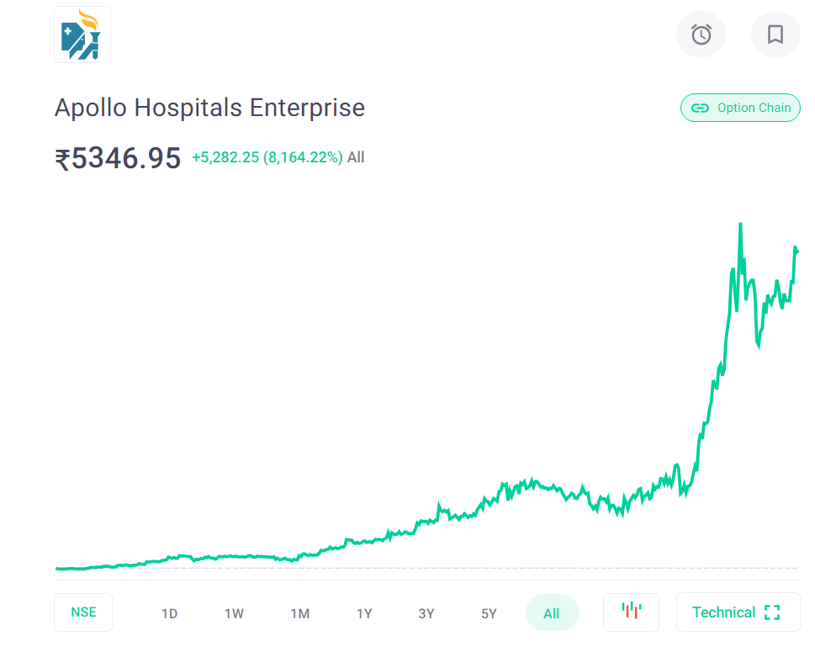STOCK MARKET GRAPH:

For up-to-date information and the latest findings on Apollo Hospitals, you can visit their official website, check reports or publications released by the hospital or its parent company, and refer to credible news articles and research papers related to their operations performance, and achievements.

Remember that healthcare institutions like Apollo Hospitals may regularly publish reports or updates on their services, quality of care, and initiatives to improve patient outcomes. By accessing these official sources, you can get the most accurate and comprehensive understanding of their current status and any recent findings related to their operations and services.

**ADVANTAGES & DISADVANTAGES:**

**Advantages of Apollo Hospitals:**

* Quality Healthcare Services:

Apollo Hospitals are known for providing high-quality medical care, with a team of skilled doctors and medical professionals across various specialties.

* Advanced Technology and Infrastructure:

The hospitals are equipped with state-of-the-art medical technology and modern infrastructure to deliver advanced diagnostic and treatment services.

* Specialized Centres of Excellence:

Apollo Hospitals have specialized centres of excellence for various medical conditions, ensuring focused and expert care.

* Medical Tourism:

Apollo Hospitals attract international patients due to their reputation for excellence, making them a preferred destination for medical tourism.

* Research and Innovation:

Apollo Hospitals actively participate in medical research and innovation, contributing to advancements in healthcare.

* Comprehensive Healthcare Services:

They offer a wide range of medical specialties and services, covering preventive care, diagnostics, treatment, and rehabilitation.

* Social Initiatives:

Apollo Hospitals engage in various social initiatives and community outreach programs to provide healthcare to underserved communities.

**Disadvantages of Apollo Hospitals:**

* Cost of Healthcare:

Some patients may find the cost of healthcare at Apollo Hospitals relatively high, especially for advanced treatments.

* Wait Times:

Due to the high demand for their services, there might be long wait times for appointments or procedures.

* Crowded Facilities:

In some locations, the hospitals may experience overcrowding, impacting the patient experience and comfort.

* Consistency in Quality:

There might be variations in healthcare quality across different locations and departments.

* Insurance Coverage and Affordability:

Not all treatments may be covered by insurance, and some patients may find the services less affordable.

* Data Security Concerns:

Ensuring the security and privacy of patient data in a digital healthcare environment is a critical challenge.

* Regional Accessibility:

While Apollo Hospitals have a wide network, some regions might still lack easy access to their facilities.

**APPLICATIONS:**

Application of Solutions at Apollo Hospital:

These solutions can be applied in different areas of Apollo Hospital, spanning various departments and locations. By strategically implementing these applications, Apollo Hospital can enhance the overall patient experience, improve healthcare outcomes, and solidify its position as a leading healthcare provider in the region. It's important to note that each solution's success will depend on the hospital's specific needs, available resources, and the willingness to adapt and innovate.

* Healthcare Technology Integration:

Apollo Hospital can invest in integrating advanced healthcare technologies to streamline patient care, enhance diagnostics, and improve treatment outcomes. This application can be employed across various departments, such as telemedicine for remote consultations, AI-driven diagnostics, and electronic health records (EHR) for efficient data management.

* Patient Appointment Scheduling System:

Implementing an efficient appointment scheduling system can help reduce patient wait times and improve the overall patient experience. This application can be deployed in outpatient departments and specialty clinics to manage patient flow effectively.

* Quality Assurance and Standardization:

To address inconsistencies in healthcare quality, Apollo Hospital can establish robust quality assurance programs and standardize protocols and best practices across all facilities. This application can ensure that patients receive consistent and high-quality care, regardless of the location they visit.

* Patient Data Security Measures:

Strengthening data security measures and adhering to industry best practices can protect patient information and maintain patient trust. This application can be applied to all aspects of data handling, including electronic health records, communication systems, and patient portals.

* Affordable Healthcare Packages:

Introducing affordable healthcare packages and payment plans for certain treatments or procedures can address the concern of healthcare affordability for some patients. This application can help expand access to critical medical services.

* Continuous Staff Training and Development:

Investing in the training and professional development of healthcare staff can improve their skills and knowledge, enhancing patient care and satisfaction. This application can be implemented hospital-wide and across different departments.

* Infrastructure Upgrades and Expansion:

Apollo Hospital can undertake infrastructure upgrades and expand facilities to accommodate increasing patient demand and ensure a comfortable environment for patients. This application can include building new wings, renovating existing units, and upgrading medical equipment.

* Community Outreach Programs:

Strengthening community outreach programs can help reach underserved populations and improve healthcare access. This application can involve health camps, awareness campaigns, and partnerships with local organizations.

* Collaboration with Insurance Providers:

Collaborating with insurance providers and offering cashless treatment options can enhance patient affordability and ease the financial burden on patients. This application can be extended to various medical services and treatments.

**CONCLUSION:**

While Apollo Hospitals has achieved considerable success, it also faces challenges that require attention and continuous improvement. These may include issues related to affordability, wait times, and ensuring consistency in healthcare quality across all its facilities.

Overall, Apollo Hospitals remains a beacon of healthcare excellence, contributing to the well-being of patients, and making significant contributions to the advancement of healthcare in India and beyond. Its dedication to patient care, technology-driven approach, and commitment to research positions it as a crucial player in the healthcare industry, continuing to set new standards for quality medical care.

**FUTURE SCOPE:**

As a leading healthcare institution, Apollo Hospitals can further enhance its future scope by adopting innovative strategies and leveraging technology to improve patient care and expand its reach. Here are some potential areas for enhancement:

* Telemedicine and Remote Care:

Expanding telemedicine services can allow Apollo Hospitals to reach patients in remote areas, both within India and globally. Implementing secure telemedicine platforms can enable virtual consultations, remote monitoring, and follow-up care, increasing accessibility and convenience for patients.

* AI-driven Healthcare Solutions:

Incorporating artificial intelligence (AI) into various aspects of healthcare, such as diagnostics, treatment planning, and personalized medicine, can lead to more accurate and efficient patient care. AI can analyse vast amounts of medical data and assist healthcare professionals in making informed decisions.

* Digital Health Records and Interoperability:

Adopting comprehensive electronic health records (EHR) systems and ensuring interoperability between different healthcare providers can improve the efficiency of patient information sharing, leading to better coordination and continuity of care.

* Focus on Preventive Healthcare:

Shifting emphasis towards preventive healthcare initiatives can help in early detection and management of health conditions, reducing the burden of diseases and improving overall population health.

* Remote Monitoring and Home Healthcare:

Implementing remote patient monitoring solutions and home healthcare services can allow Apollo Hospitals to extend care beyond the hospital setting, especially for chronic disease management and post-operative recovery.

Enhancing patient engagement through mobile apps and online platforms can empower patients to actively participate in their healthcare journey, leading to better treatment adherence and outcomes.

* Collaboration with Research Institutions:

Strengthening collaborations with research institutions and academic centres can facilitate groundbreaking medical research, promoting innovation, and driving advancements in healthcare.

* Sustainable Healthcare Practices:

Incorporating environmentally sustainable practices in hospital operations can contribute to reducing the environmental impact of healthcare facilities and promoting a greener future.

* Expanded Specialties and Super-Specialties:

Introducing new specialized services and super-specialties can cater to a broader range of medical conditions and attract patients seeking specialized care.

* Medical Training and Skill Development:

Investing in continuous medical education and skill development programs for healthcare professionals can enhance the expertise and knowledge of the hospital's workforce.

* Healthcare Tourism Promotion:

Focusing on healthcare tourism marketing efforts can attract more international patients, contributing to the growth of medical tourism and strengthening India's position as a healthcare destination.

By embracing these enhancements and continuously striving for excellence, Apollo Hospitals can further solidify its position as a leader in the healthcare industry, providing exemplary patient care and advancing medical science for a healthier future.